Question 2.
You are tasked with cleaning and transforming text data using regular expressions in Python. Complete the following sub-questions:
(a) Substitution
The following text contains British English spellings:
"The theatre is colourful. That color is marvellous!"
Write a regex substitution that converts all spellings to American English (theater, color, marvelous).
Code and Output:
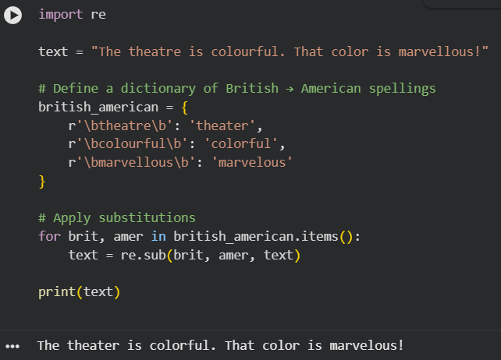

(b) Capture Groups (single)
Given the string:
"Item 123 costs $45. Item 567 costs $99."
Use a regex substitution with capture groups to transform this into:
"[123]: $45"
"[567]: $99"

Code and Output:
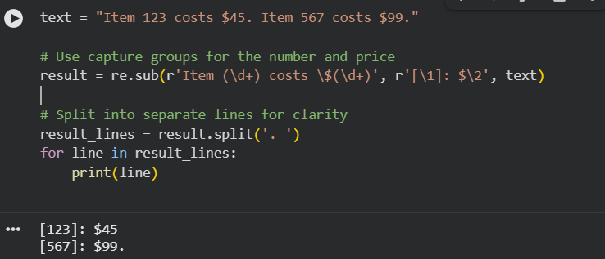
(c) Capture Groups (multiple)
You have a list of names in "Last, First" format:
"Smith, John; Doe, Jane; Brown, Charlie"
Write a regex substitution that reformats the names into "First Last" format.
Code and Output:
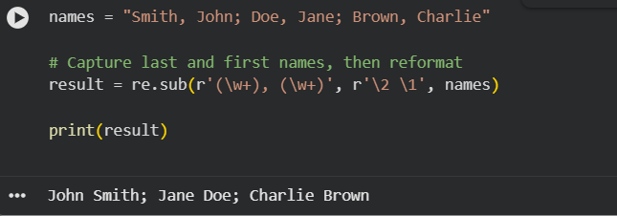

(d) Non-Capturing Groups
Consider these sentences:
"Some cats like some cats."
"A few people like some people."
"Some some like some some."
Write a regex that matches the first two valid sentences but excludes the third one.
(Hint: use (?: ... ) for non-capturing groups.)
Code and Output:
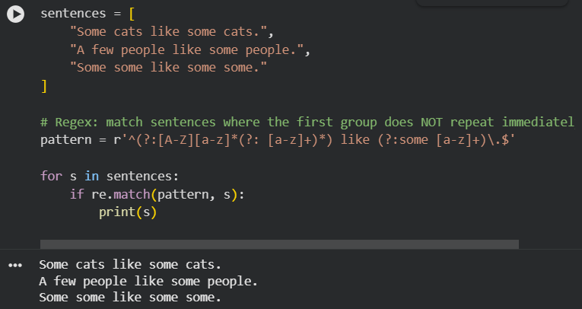
(e) Lookahead Assertions
Write a single regex that validates passwords with the following rules:
- At least 8 characters long
- Must contain at least one digit
- Must contain at least one uppercase letter
Examples:
- Password123 → valid
- password → invalid
- PassWord → invalid (no digit)
Code and Output:
